- Enable CloudTrail monitoring and store the events in S3 and CloudWatch log events.
Step 1: Create an S3 Bucket
- Go to AWS Console → S3
- Click Create bucket
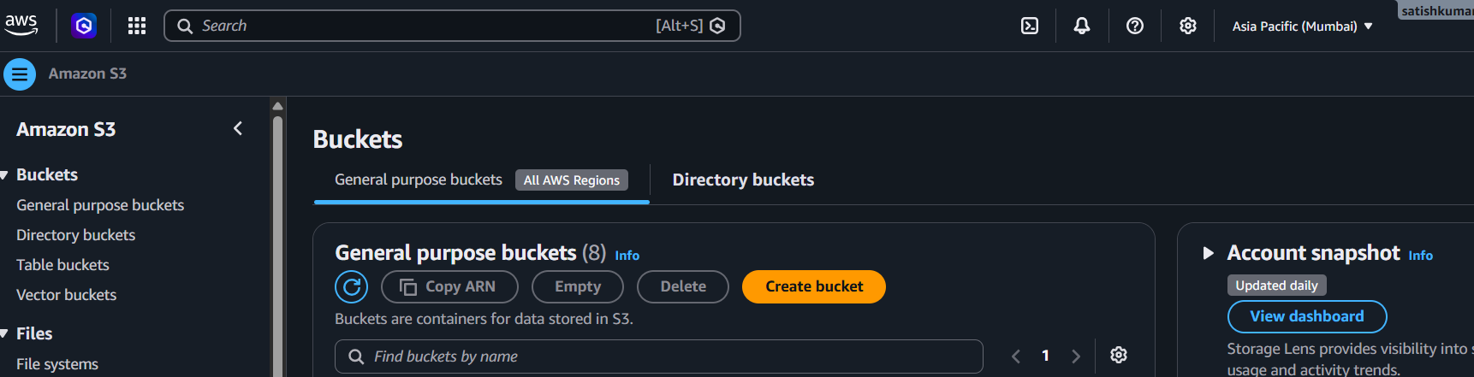
- Enter a unique bucket name (e.g., my-cloudtrail-logs-123)
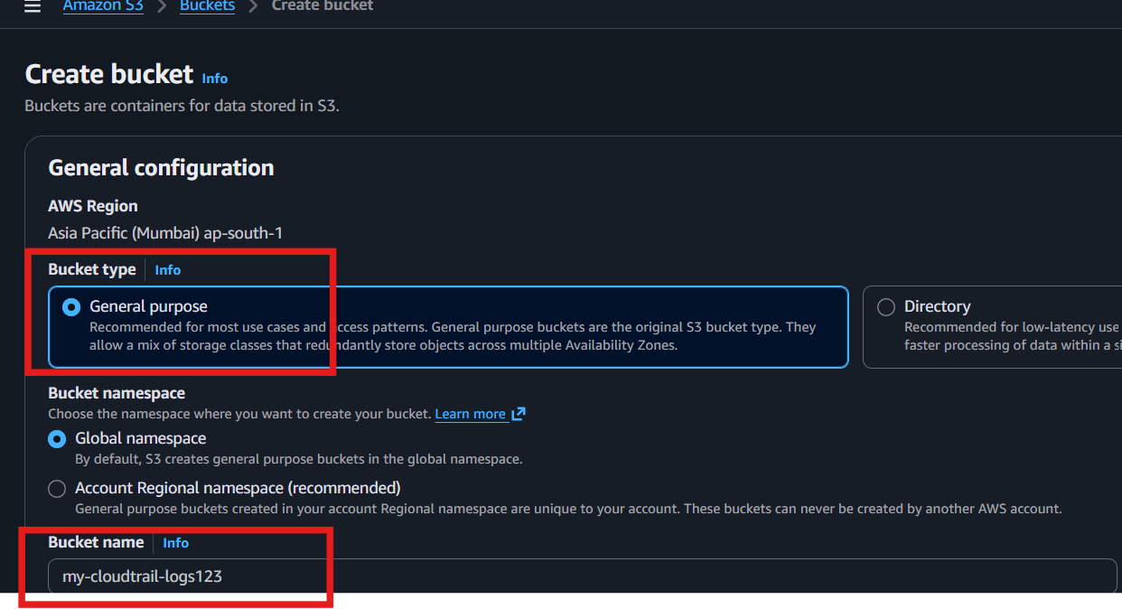
- Leave default settings
- Click Create bucket
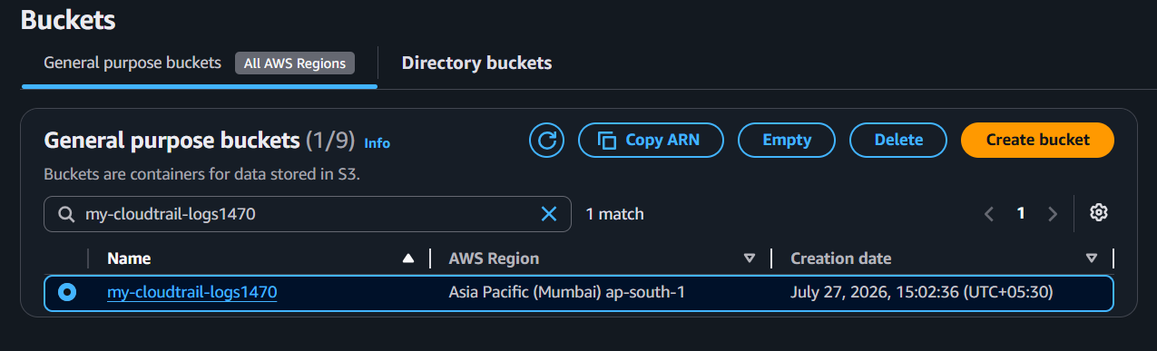

Step 2: Create a CloudWatch Log Group
- Go to CloudWatch → Logs → Log Groups
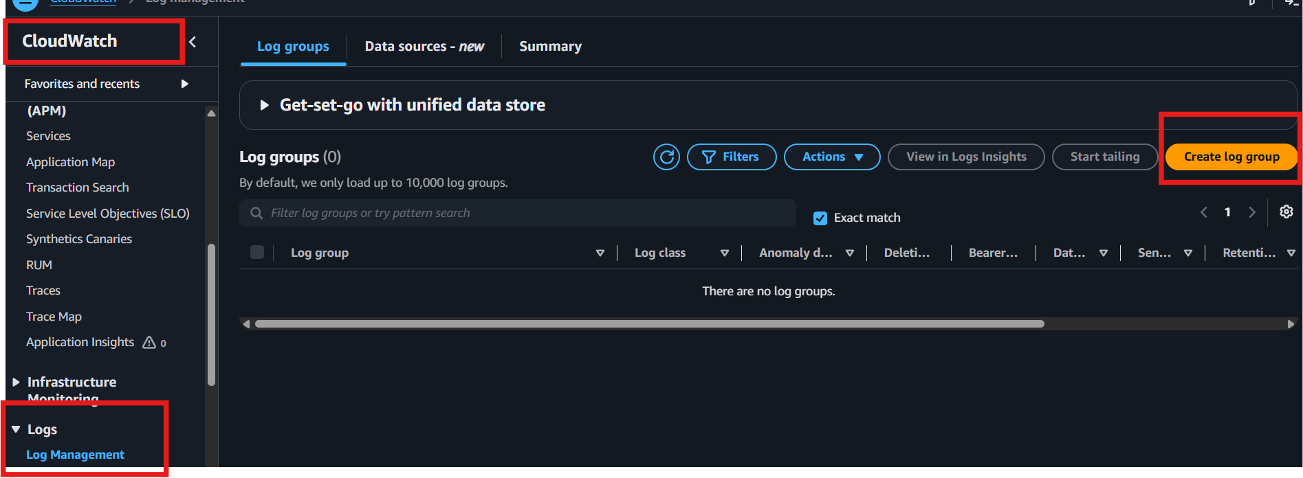
- Click Create log group
- Enter name: CloudTrailLogs
- Click Create
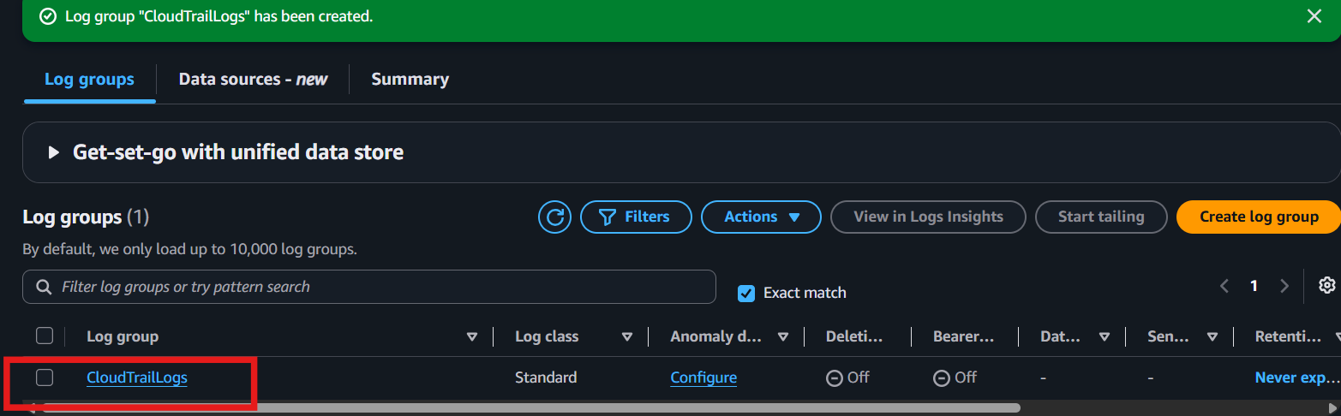

Step 3: Open CloudTrail
- Go to CloudTrail
- Click Trails
- Click Create trail
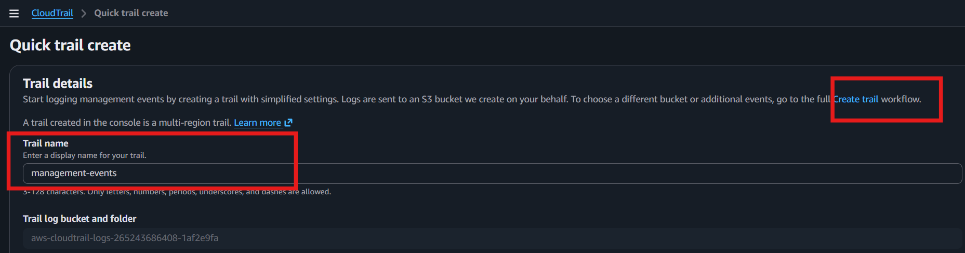

Step 4: Create Trail
- Trail name: MyTrail
- Storage location: Select the S3 bucket created in Step 1
- Keep Management events enabled
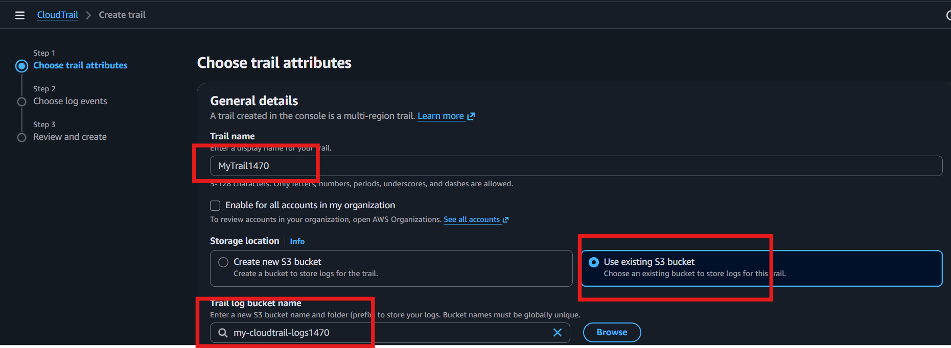
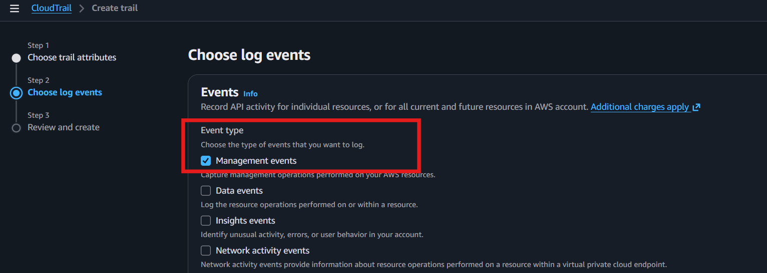

Step 5: Enable CloudWatch Logs
- Scroll to CloudWatch Logs
- Check Enable
- Select the CloudWatch Log Group (CloudTrailLogs)
- Click Create new IAM Role (or select an existing role)
- AWS automatically creates the required permissions
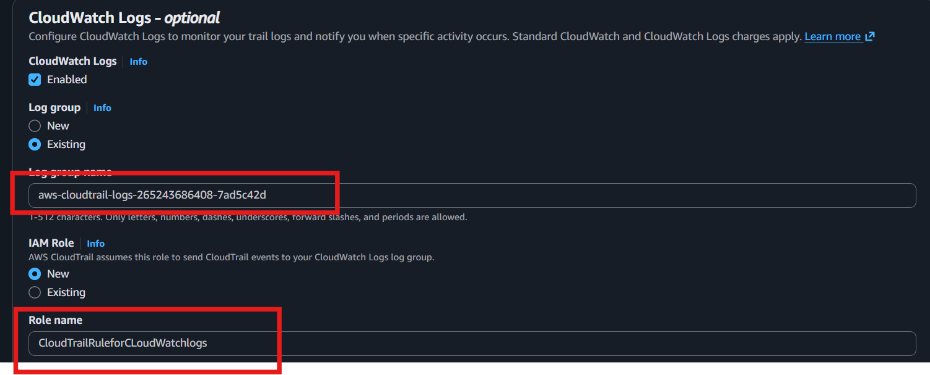

Step 6: Create the Trail
- Review the settings
- Click Create trail
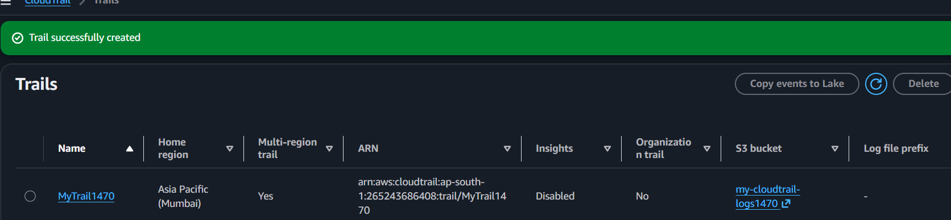

Step 7: Generate Activity
Perform any AWS action, such as:
- Launch an EC2 instance
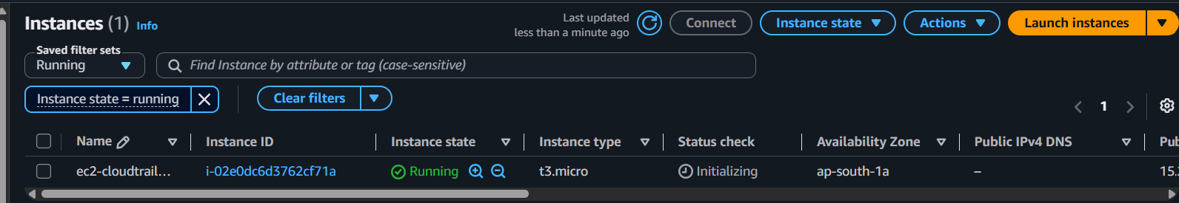
- Create an S3 bucket
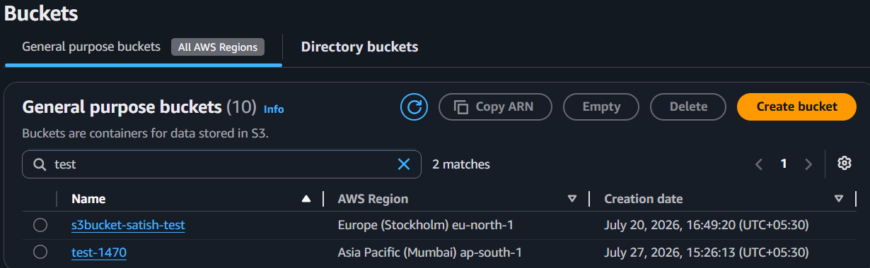
- Stop/Start an EC2 instance
CloudTrail records these events.

Step 8: Verify Logs in S3
- Go to S3
- Open your CloudTrail bucket
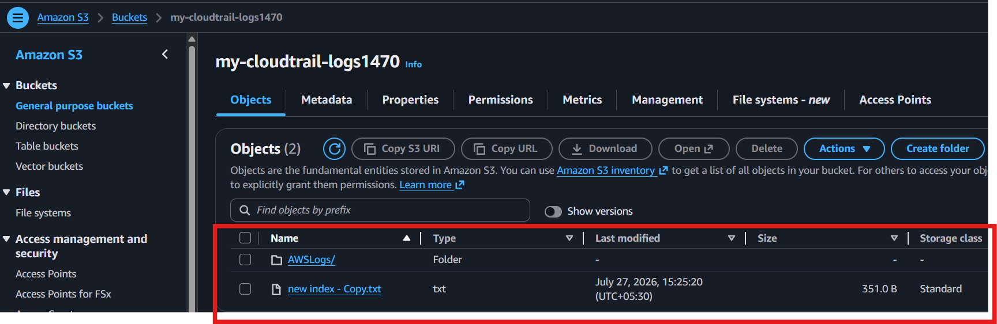
- Navigate to:
AWSLogs → Account-ID → CloudTrail → Region → Year → Month → Day
- You will find .json.gz log files.
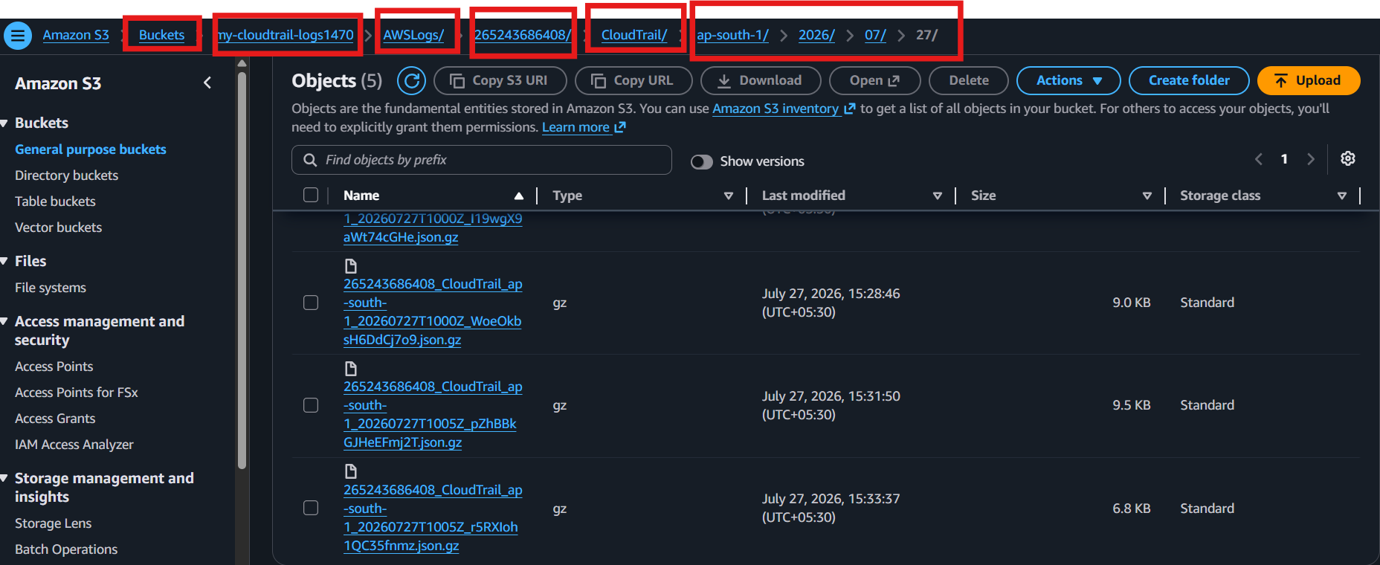

Step 9: Verify Logs in CloudWatch
- Go to CloudWatch → Logs → Log Groups
- Open CloudTrailLogs
- Open the latest Log Stream

- View the recorded AWS API events.
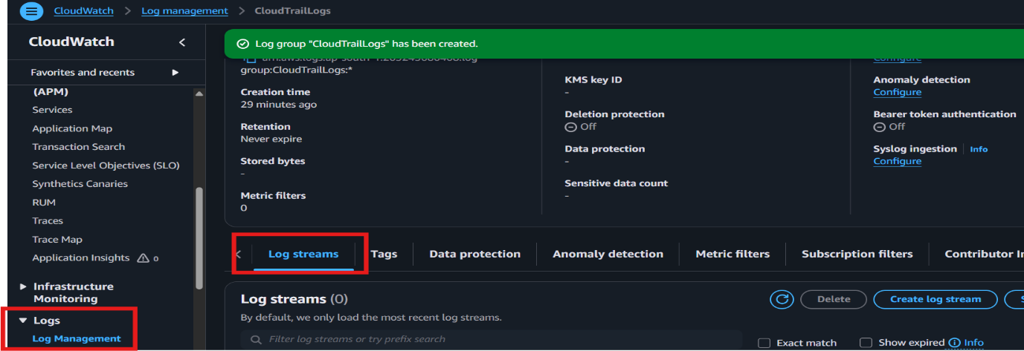
- note : it will take 5-6 hours to steam logs

- Enable SNS for CloudTrail to send alerts via email.
Step 1: Create an SNS Topic
- Go to SNS → Topics
- Click Create topic
- Select Standard
- Topic name: CloudTrailAlerts
- Click Create topic
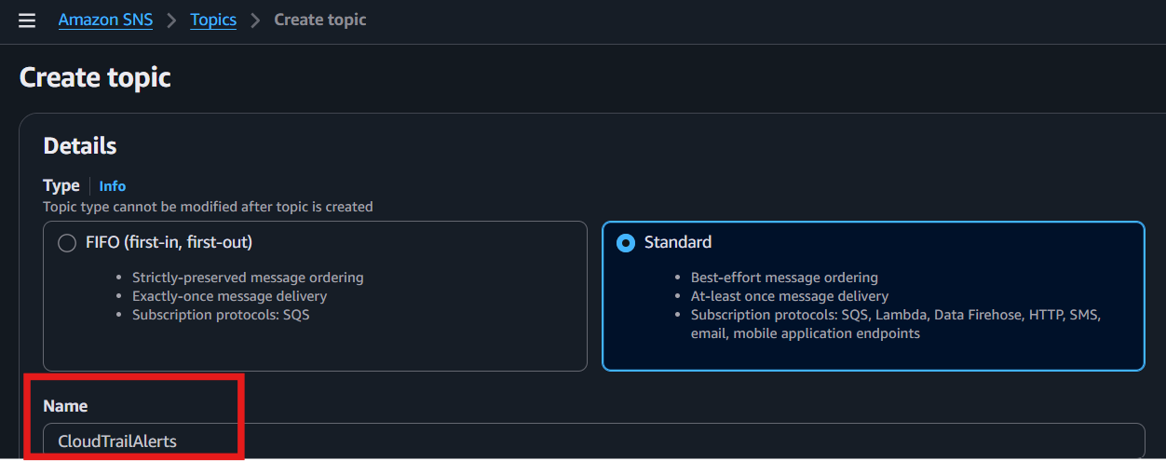

Step 2: Create an Email Subscription
- Open the CloudTrailAlerts topic
- Click Create subscription
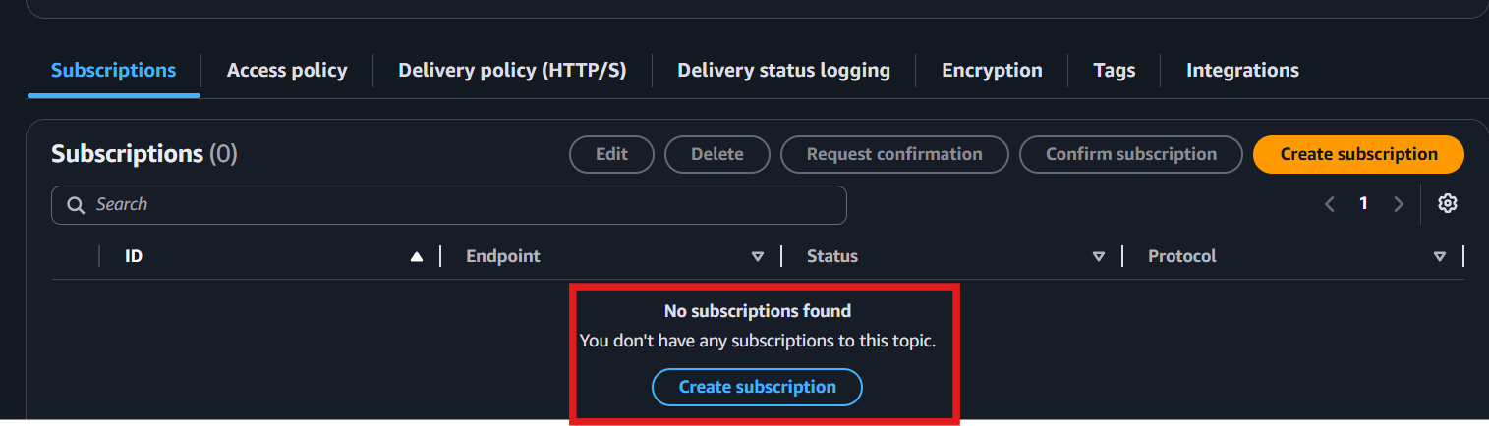
- Protocol: Email
- Endpoint: Enter your email address
- Click Create subscription
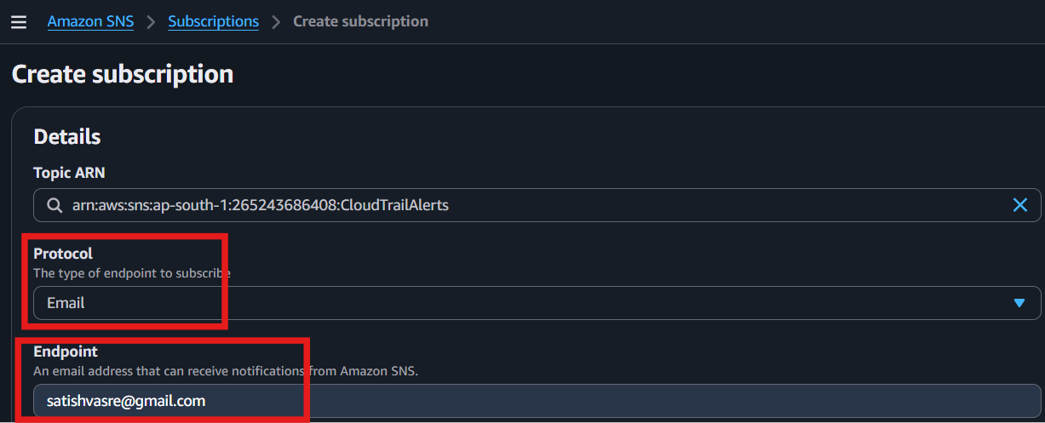
After subscription aws send notification to email
- Open your email and click Confirm subscription
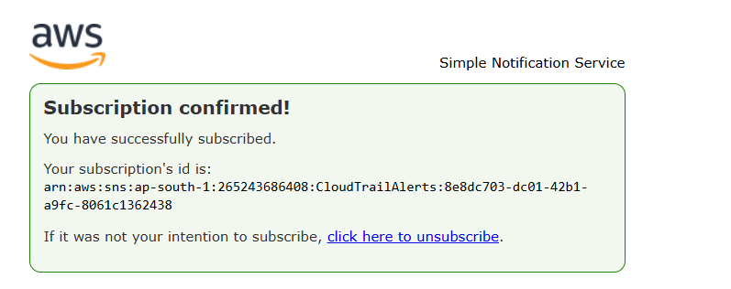

Step 3: Create a CloudWatch Alarm (or Metric Filter)
- Go to CloudWatch → Logs → Log Groups
- Open the CloudTrailLogs log group
- Create a Metric Filter
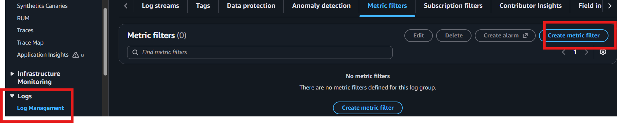
- Create a CloudWatch Alarm based on that metric
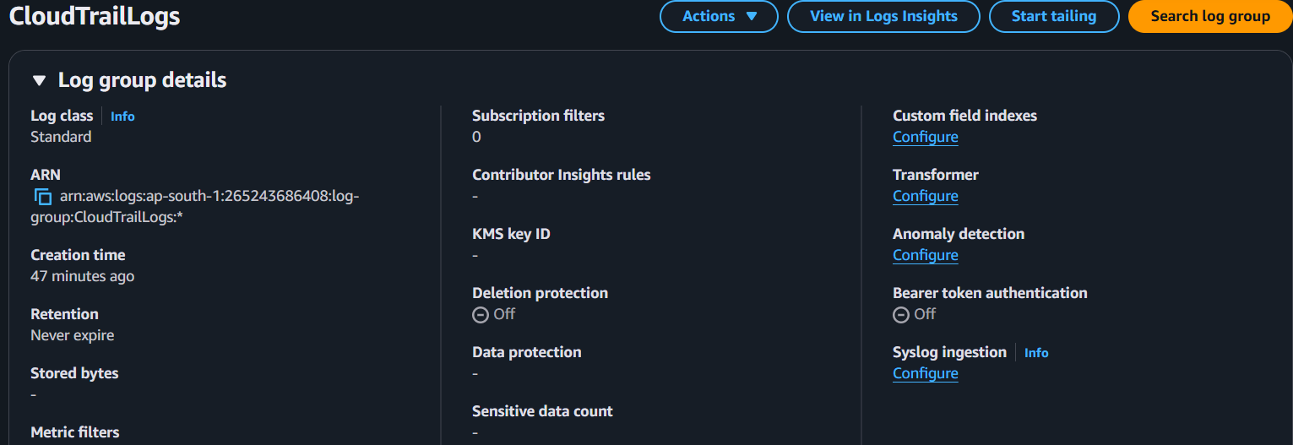

Step 4: Attach SNS to the Alarm
- In the alarm configuration:
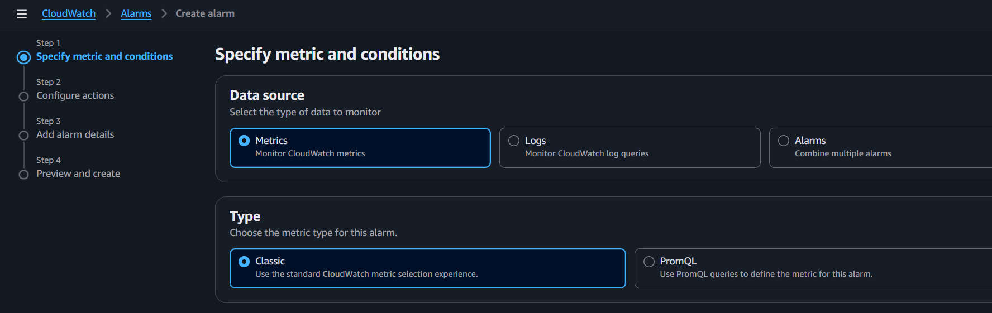
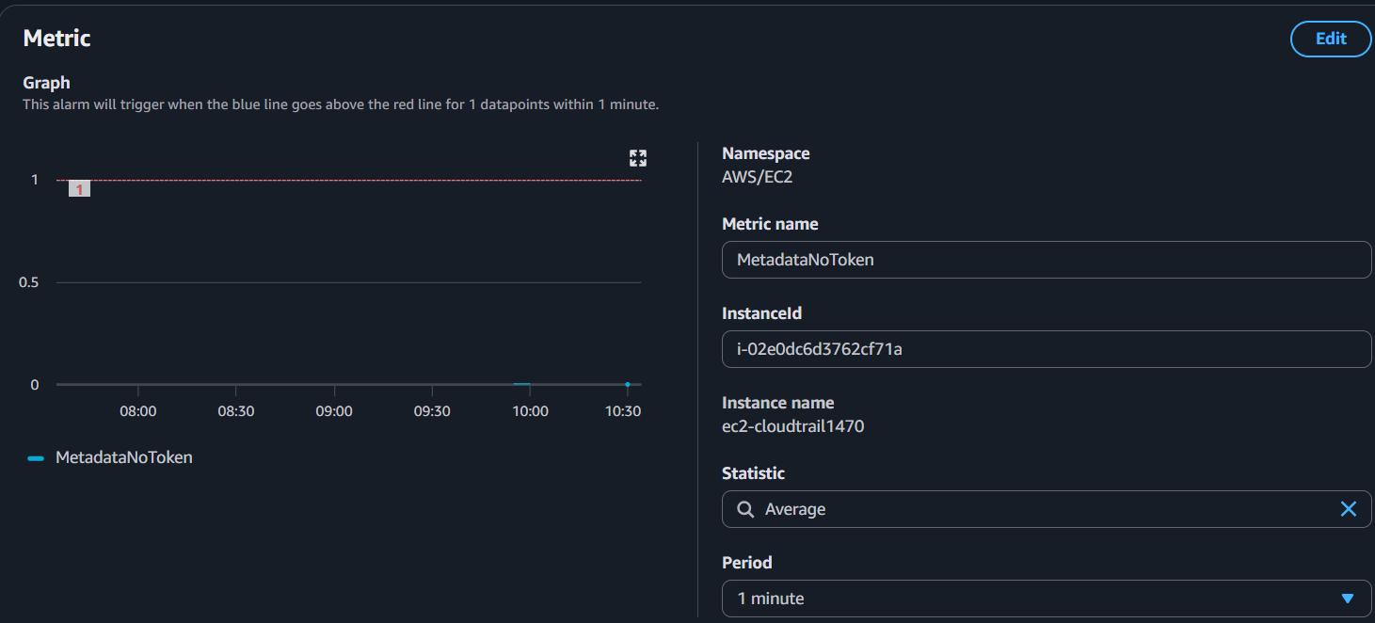
  - Notification: Select SNS Topic
  - Choose CloudTrailAlerts
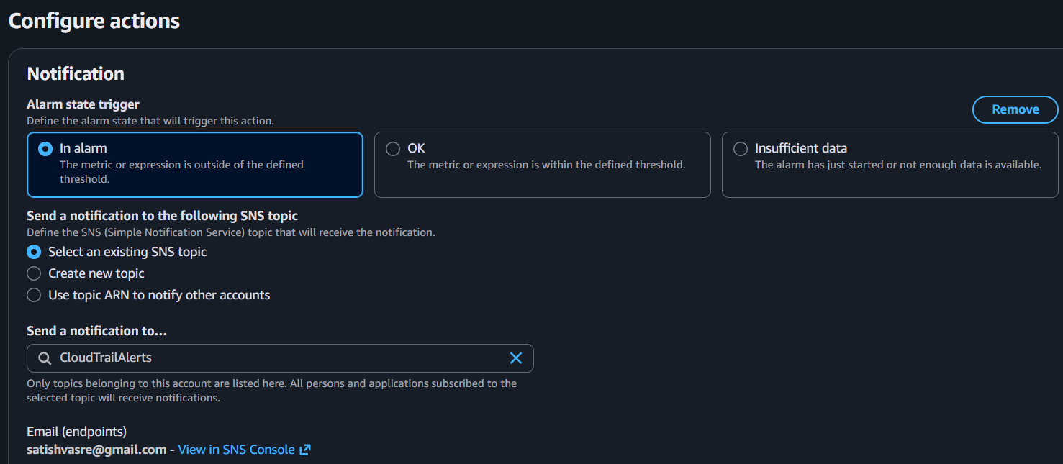
- Finish creating the alarm
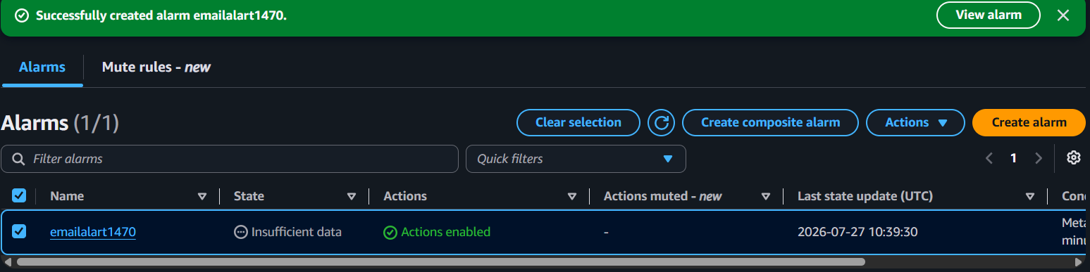

Step 5: Test the Alert (Short)
- Perform the event you are monitoring (e.g., IAM → Create User).
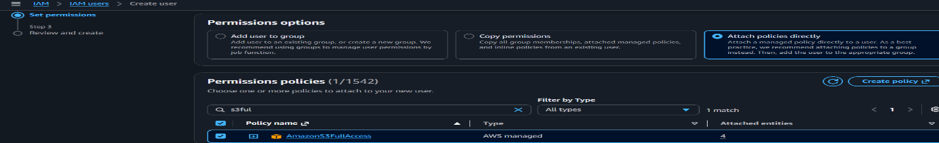
- Wait 2–5 minutes.
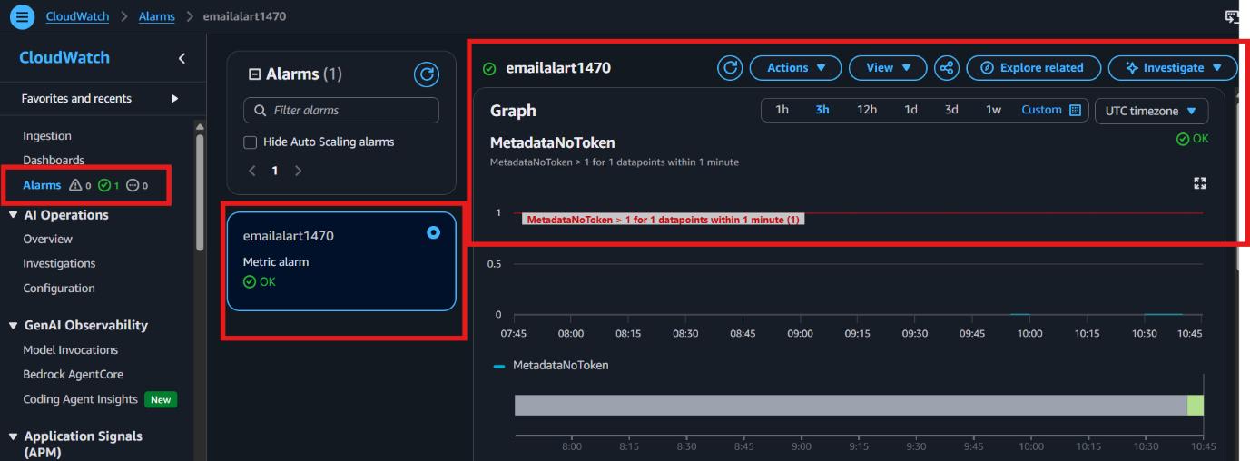
- Go to CloudWatch → Alarms and verify the alarm changes to In Alarm.

- Check your email for the SNS notification.
- If you receive the email, the setup is working successfully.

- Configure CloudWatch monitoring and record the CPU utilization and other metrics of EC2.
Step 1:
Go to EC2 → Instances and select your EC2 instance.
Step 2:
Click the Monitoring tab.
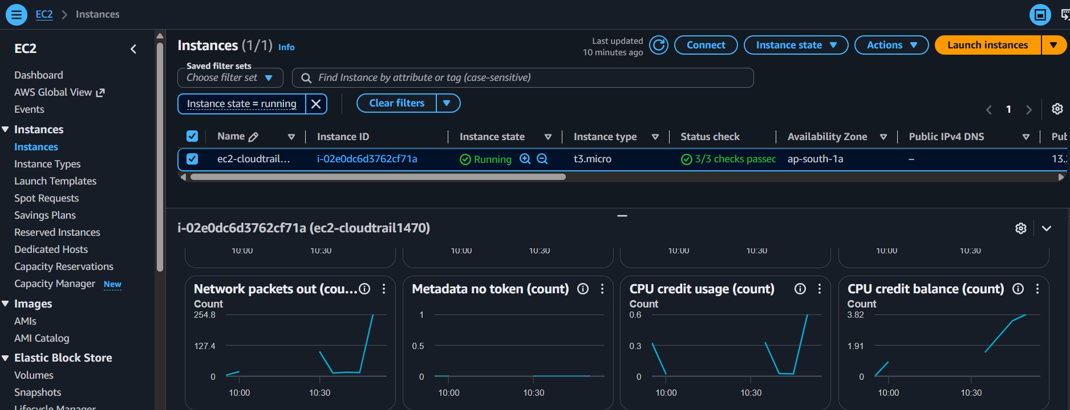

Step 3:
Click Manage detailed monitoring → Enable Detailed Monitoring (1-minute) → Save
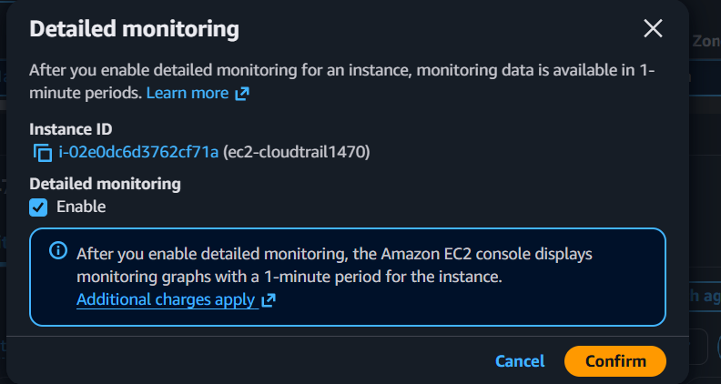
Step 4:
Go to CloudWatch → Metrics → EC2 → Per-Instance Metrics.
Step 5:
View EC2 metrics such as:
- CPUUtilization
- NetworkIn
- NetworkOut
- DiskReadBytes
- DiskWriteBytes
- StatusCheckFailed
Verification:
Go to CloudWatch → Metrics and confirm that CPU utilization and other EC2 metrics are being recorded.
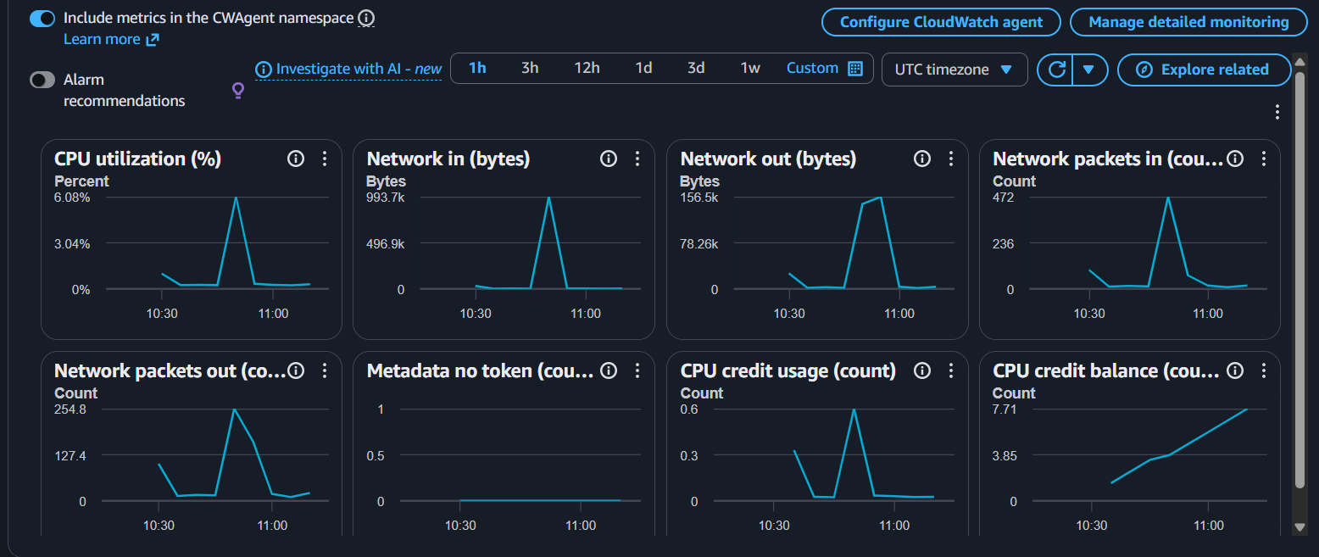

- Create one alarm to send an alert to email if the CPU utilization is more than 70 percent.
Step 1:
Go to CloudWatch → Alarms → Create alarm. 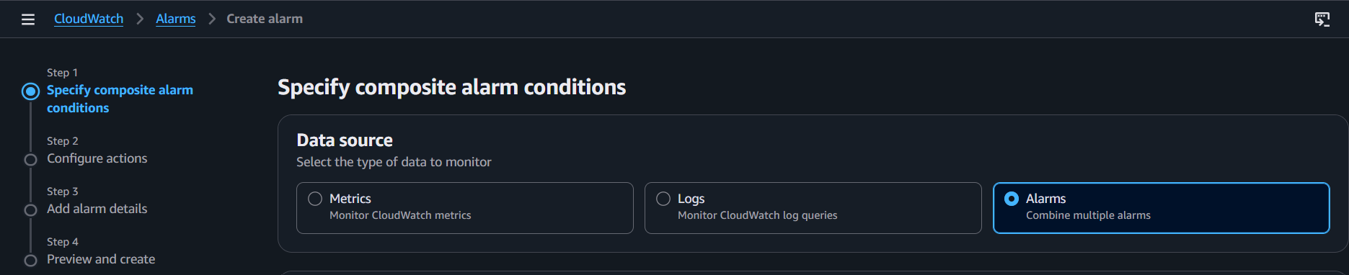
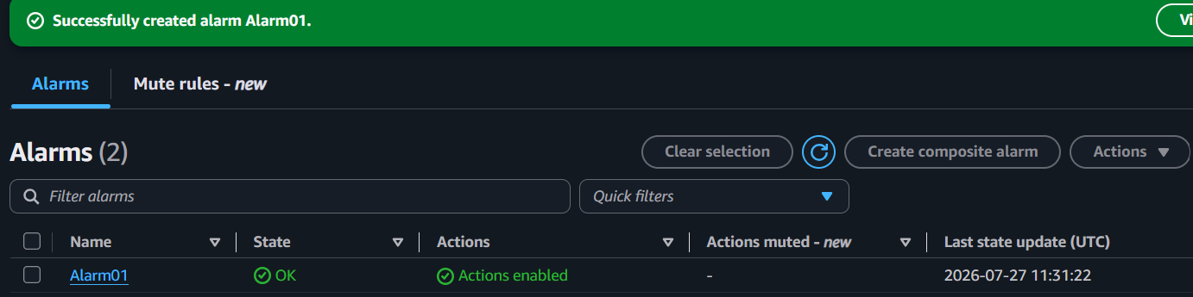
Step 2:
Click Select metric → AWS/EC2 → By InstanceId → Select your EC2 instance → CPUUtilization → Select metric.
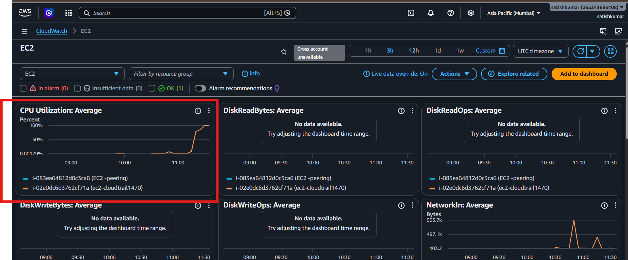
Step 3:
Set the alarm condition:
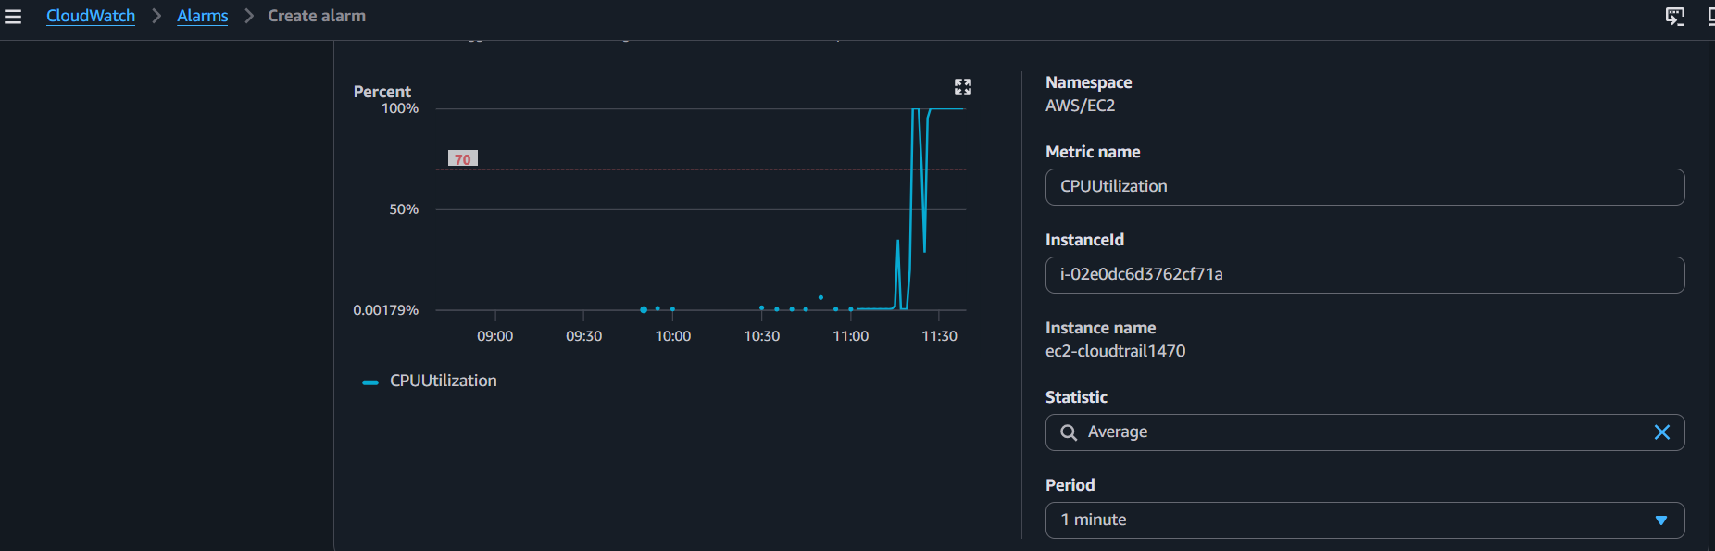
- Threshold type: Static
- Whenever CPUUtilization is ≥ 70
- Click Next
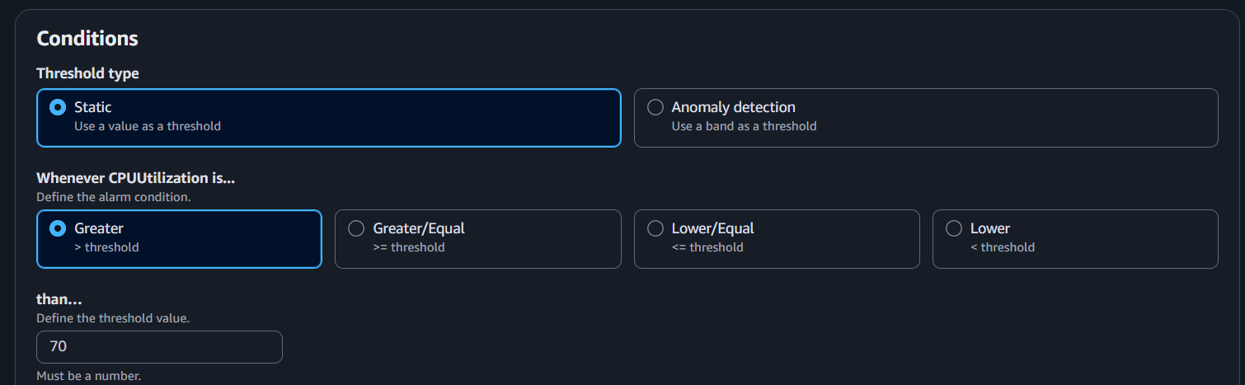
Step 4:
Configure notifications:
- Select In alarm
- Choose your SNS Topic (e.g., CloudTrailAlerts)
- Click Next

Step 5:
Enter an alarm name (e.g., EC2-CPU-70-Alarm) and click Create alarm.
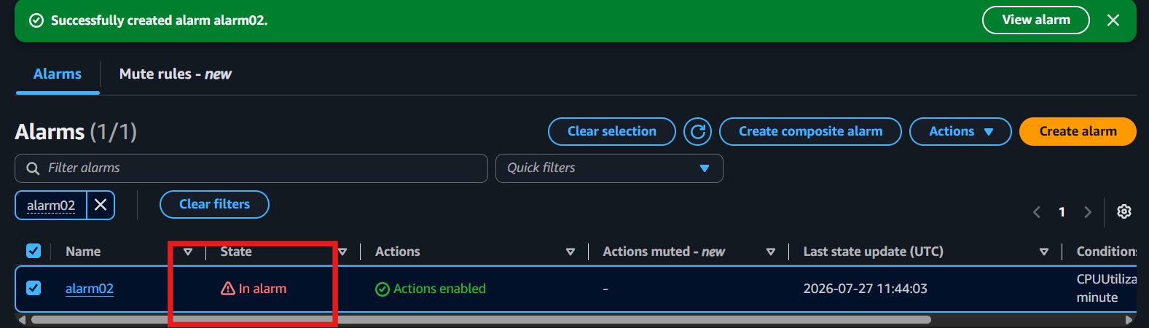
Step 6 (Test):
Increase CPU usage on the EC2 instance (for example, run a CPU stress command), wait a few minutes, then:
- Check CloudWatch → Alarms (status should change to In alarm).
- Check your email for the SNS notification.
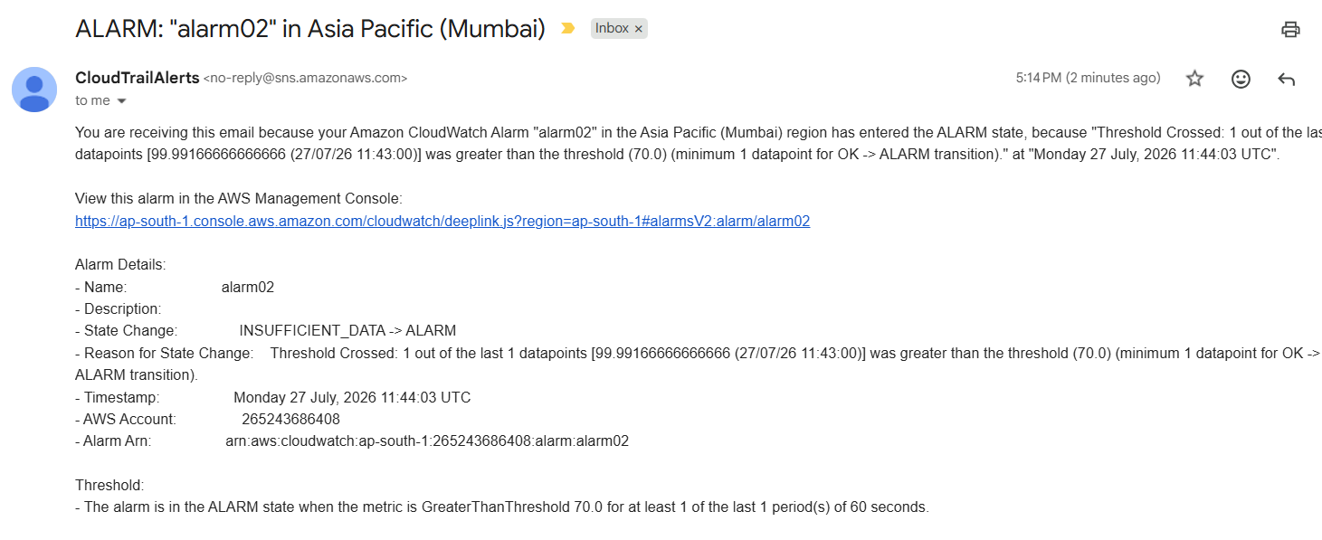

- Create a Dashboard and monitor the Tomcat service whether it is running or not and send the alert.
To monitor whether Tomcat is running, you need the CloudWatch Agent because the default CloudWatch metrics do not monitor Linux services.
Step 1: Install CloudWatch Agent
sudo dnf install amazon-cloudwatch-agent -y
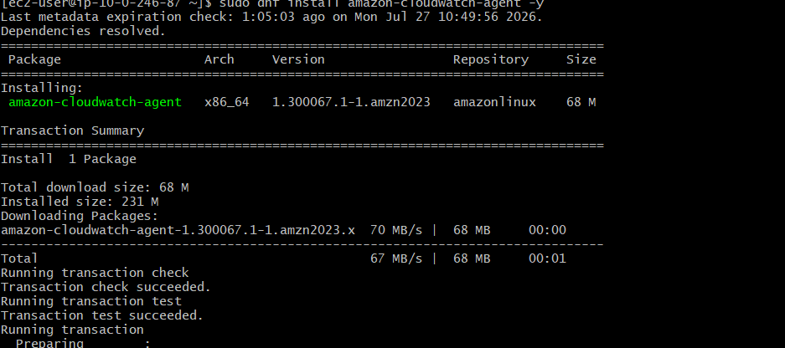

Step 2: Configure the Agent
sudo /opt/aws/amazon-cloudwatch-agent/bin/amazon-cloudwatch-agent-config-wizard
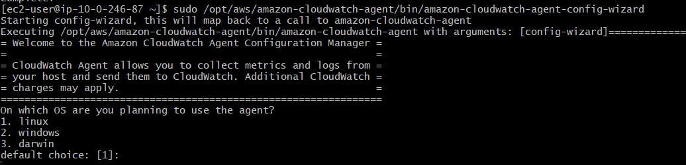
Enable Procstat monitoring and specify the process name: tomcat

Step 3: Start the Agent
sudo systemctl enable amazon-cloudwatch-agent
sudo systemctl start amazon-cloudwatch-agent

Step 4: Create a Dashboard
- Go to CloudWatch → Dashboards
- Click Create dashboard
- Add a Line widget
- Select CWAgent → procstat metrics
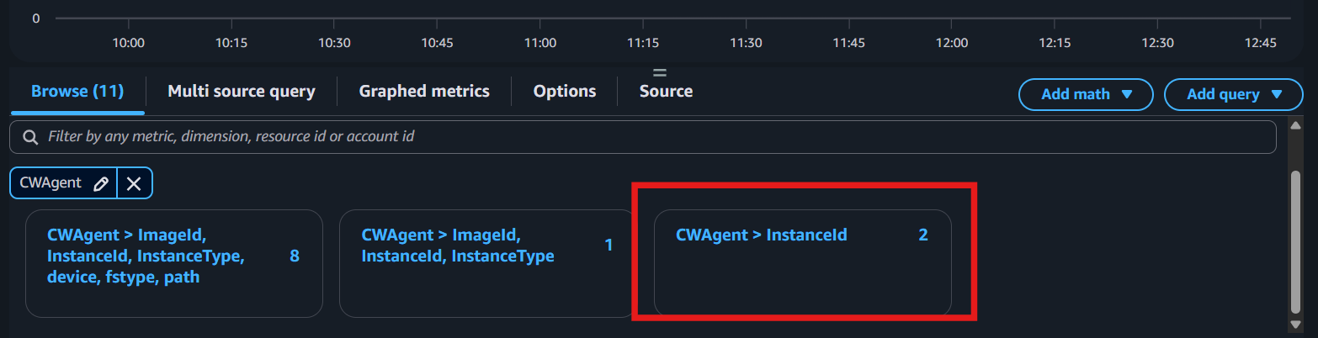
- Add the metric for the Tomcat process
- Save the dashboard
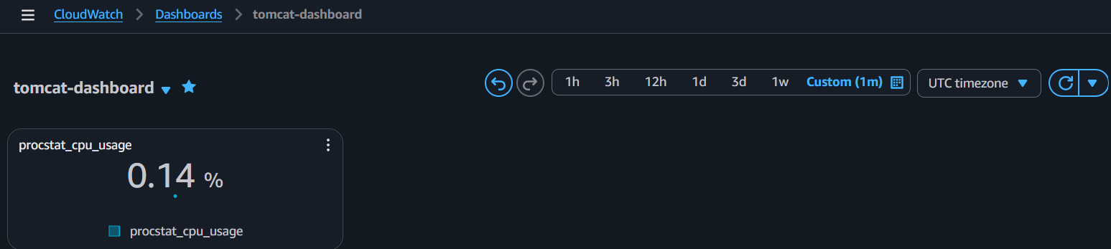

Step 5: Create an Alarm
- Go to CloudWatch → Alarms → Create alarm
- Select the procstat metric
- Set the condition:
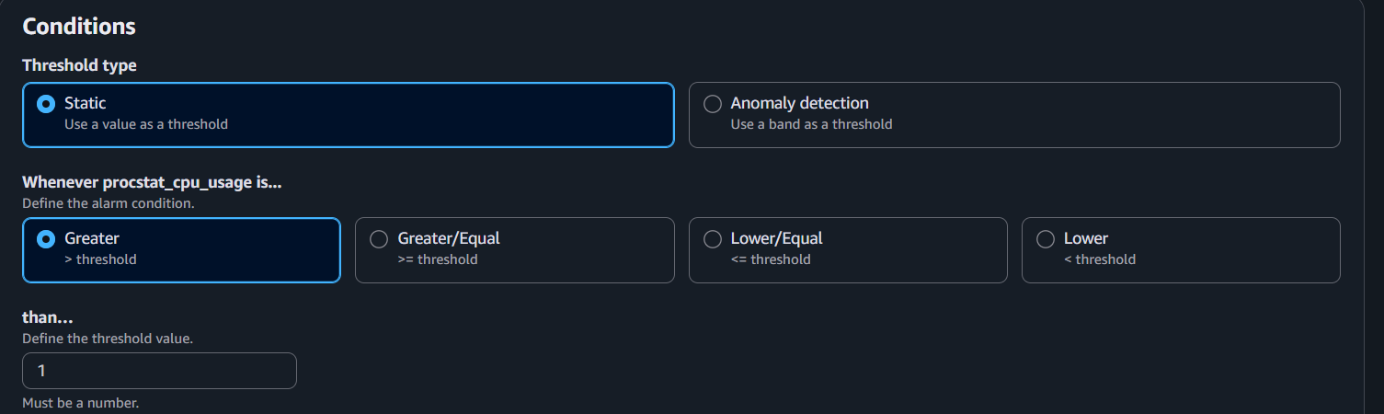
  - procstat_running < 1

- Select your SNS Topic
- Click Create alarm
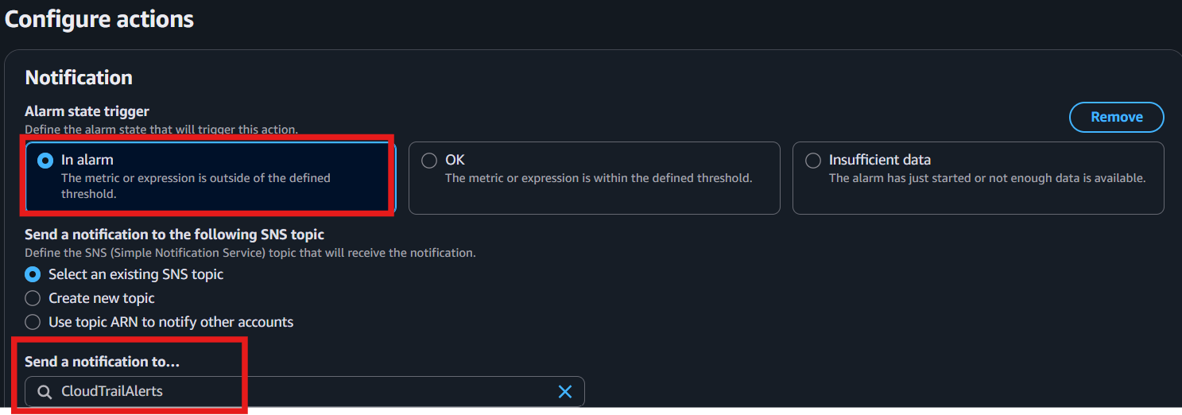

Step 6: Test
Stop Tomcat: sudo systemctl stop tomcat 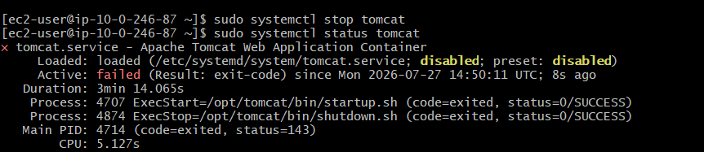
Wait 2–5 minutes:
- The dashboard will show the process is not running.
- The CloudWatch alarm changes to In alarm.
- You receive an SNS email.

- Create a Dashboard and monitor the Nginx service to send the alert if Nginx is not running.
1. Install CloudWatch Agent
On EC2:
sudo yum install amazon-cloudwatch-agent -y 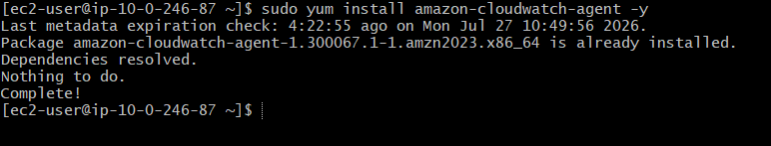

2. Configure Procstat to Monitor Nginx
Edit config:
sudo vi /opt/aws/amazon-cloudwatch-agent/etc/amazon-cloudwatch-agent.json
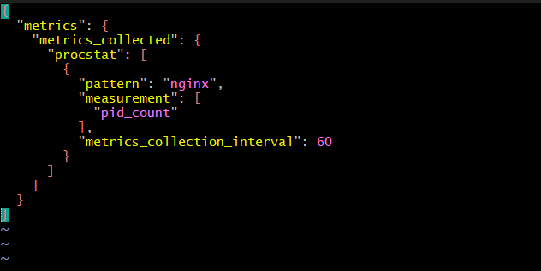

3. Start CloudWatch Agent
sudo systemctl restart amazon-cloudwatch-agent
Check:
sudo systemctl status amazon-cloudwatch-agent 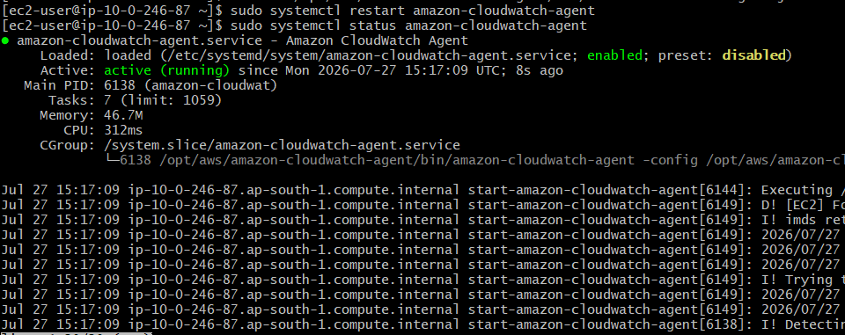

4. Verify Nginx Process Metric
AWS Console:
CloudWatch
↓
Metrics
↓
CWAgent
↓
procstat
Check:
procstat_lookup_pid_count
Value:
- 1 → Nginx running
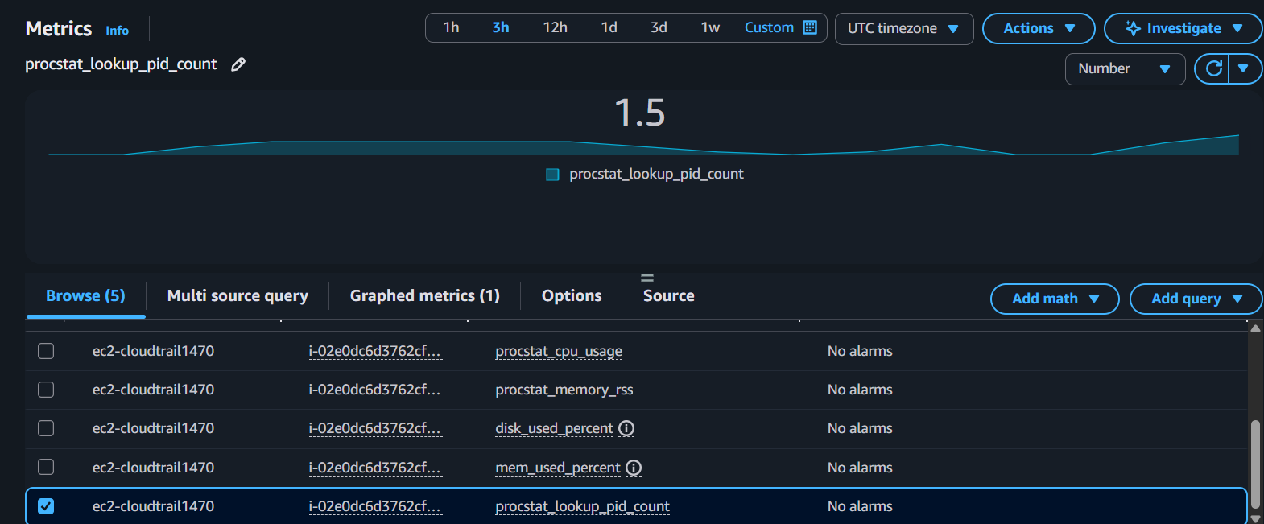
- 0 → Nginx stopped

5.Create SNS Topic
SNS → Create Topic → Create Subscription → Protocol: Email → Confirm Email
If already created ignore this step
6. Create CloudWatch Alarm
CloudWatch → Alarms → Create Alarm
Select Metric ---CWAgent → procstat → pid_count
Set Condition
Statistic: Minimum
Period: 1 minute
Threshold: Less than 1

Meaning: Nginx process not found = Alarm 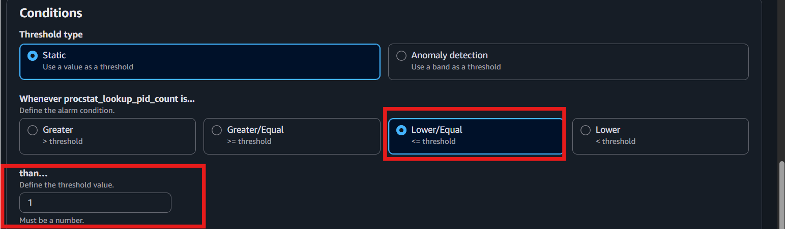

6. Create SNS Notification
Attach SNS topic to CloudWatch Alarm.

- Create Dashboard

1. Open Dashboard
CloudWatch → Dashboards → Create Dashboard
2. Enter Name
Name: Nginx-Monitoring
3. Add Widget
Add Widget → Line Graph
4. Select Metric
Metrics → CWAgent → procstat → pid_count
5. Save Dashboard

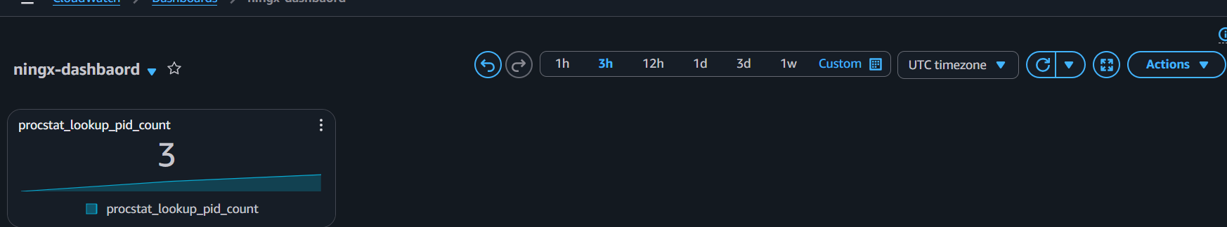

8. Test Alert
Stop Nginx:
sudo systemctl stop nginx
Wait 1–2 minutes.
Check:
CloudWatch Alarm → ALARM state
Email alert received.


